

Al-Based Internship Recommendation Engine for PM Internship Scheme
A PROJECT REPORT

Submitted by
SINDHU L Y - 20221ISE0162
ANUSHA M S - 20221ISE0171
KUMAR G K - 20231ISE3001

Under the guidance of,
Dr. Prajeesh C B
BACHELOR OF TECHNOLOGY
IN
INFORMATION SCIENCE AND ENGINEERING
PRESIDENCY UNIVERSITY
BENGALURU
APRIL 2026


PRESIDENCY SCHOOL OF COMPUTER SCIENCE AND ENGINEERING
BONAFIDE CERTIFICATE
Certified that this report “AI-BASED INTERNSHIP RECOMMENDATION ENGINE FOR PM INTERNSHIP SCHEME” is a bonafide work of “SINDHU L Y(20221ISE0162), ANUSHA M S(20221ISE0171), KUMAR (20231ISE3001)”, who have successfully carried out the project work and submitted the report for partial fulfilment of the requirements for the award of the degree of BACHELOR OF TECHNOLOGY in INFORMATION SCIENCE AND ENGINEERING, during 2025-26.

Dr. Prajeesh C B  Associate Professor  Project Guide  PSCS  Presidency University | Ms. Suma N G  Associate Professor  Program Project Coordinator  PSCS  Presidency University | Dr. Sampath A K  Professor  School Project Coordinators  PSCS  Presidency University

Dr. Gopal Krishna Shyam  Professor & Head of the Department  PSCS  Presidency University | Dr. Shakkeera L  Associate Dean  PSCS  Presidency University

Sl. No | Name of the Examiner | Signature | Date
01
02




PRESIDENCY SCHOOL OF INFORMATION SCIENCE AND ENGINEERING

DECLARATION

We the students of final year B.Tech in INFORMATION SCIENCE AND ENGINEERING at Presidency University, Bengaluru, named SINDHU L Y, ANUSHA M S, KUMAR G K, hereby declare that the project work titled “AI-BASED INTERNSHIP RECOMMENDATION ENGINE FOR PM INTERNSHIP SCHEME” has been independently carried out by us and submitted in partial fulfillment for the award of the degree of B.Tech in INFORMATION SCIENCE AND ENGINEERING during the academic year of 2025-26. Further, the matter embodied in the project has not been submitted previously by anybody for the award of any Degree or Diploma to any other institution.

Sindhu L Y 20221ISE0162

Anusha M S 20221ISE0171

Kumar G K 20231ISE3001

PLACE: BENGALURU

DATE:



ACKNOWLEDGEMENT
For completing this project work, We/I have received the support and the guidance from many people whom I would like to mention with deep sense of gratitude and indebtedness. We extend our gratitude to our beloved Chancellor, Pro-Vice Chancellor, and Registrar for their support and encouragement in completion of the project.
I would like to sincerely thank my internal guide Dr. Prajeesh C B, Assistant Professor, Presidency School of Computer Science and Engineering, Presidency University, for her moral support, motivation, timely guidance and encouragement provided to us during the period of our project work.
I am also thankful to Dr. Gopal Krishna Shyam, Professor, Head of the Department, Presidency School of Computer Science and Engineering Presidency University, for his mentorship and encouragement.
We express our cordial thanks to Dr. Shakkeera L, Associate Dean, Presidency School of computer Science and Engineering and the Management of Presidency University for providing the required facilities and intellectually stimulating environment that aided in the completion of my project work.
We are grateful to Dr. Sampath A K, and Dr. Geetha A, PSCS Project Coordinators, Ms. Suma N G, Program Project Coordinator, Presidency School of Computer Science and Engineering, or facilitating problem statements, coordinating reviews, monitoring progress, and providing their valuable support and guidance.
We are also grateful to Teaching and Non-Teaching staff of Presidency School of Computer Science and Engineering and also staff from other departments who have extended their valuable help and cooperation.
SINDHU L Y
ANUSHA M S
KUMAR G K
Abstract
The Prime Minister Internship Scheme (PMIS) seeks to offer high-quality industry internships to many young people in the country. It is important to develop intelligent systems to automatically recommend the best internships to the applicants based on their resumes. In this paper, we propose the design and development of the AI-Based Internship Recommendation Engine for the PM Internship Scheme.Our proposed architecture is based on the hybrid model using the transformer-based semantic embeddings and rule-based keyword matching with context-based boosts. It is designed to be modular with the front end, backend API, matching engine, certificate/placement tracker. It is also designed to be optimal with the performance and explainability. Simulated resume-internship data is used to evaluate the performance of the proposed architecture. It is seen to be improved compared to the baseline.In this paper, the proposed architecture can be used with the PMIS portal to improve the quality of the candidate-position fit. The system uses adaptive learning technologies that constantly refine recommendation precision through analysis of user interactions, feedback, and outcome placements. It is designed to be scalable, guaranteeing that it will perform effectively even when handling huge numbers of candidates and internship openings. Filtering and ranking algorithms are used to highlight pertinent options, and explainable AI elements ensure that there is transparency in how recommendations are made, allowing users to gain insight into why certain internships are recommended.
In addition, the suggested system will incorporate personalization through consideration of user preferences, career objectives, as well as previous history of job applications, apart from the technical skills stated on the resumes. Data processing tools used in this case include resume parsing, skills extraction, as well as normalization to ensure accurate matching. The modular architecture of the system facilitates its easy expansion in future for incorporation of new features, for example, real-time analysis of industry demands, as well as employer feedback. Further, the system will protect applicant privacy by processing the data using secure data processing tools. Real-time updates of internships make it possible for recommendations to always reflect current internship opportunities. The recommendation engine will have a simple user-friendly interface. In addition, the system will accommodate multilingual resumes.
Keywords—Internship Recommendation, Prime Minister Internship Scheme, Hybrid Matching, Sentence Transformers, Resume Parsing.

Table of Content

Sl. No. | Title | Page No.
 | Declaration | i
 | Acknowledgement | ii
 | Abstract | iii
 | List of Figures | vi
 | List of Tables | vii
 | Abbreviations | viii
1. | Introduction  1.1 Background  1.2 Statistics of project  1.3 Prior existing technologies  1.4 Proposed approach  1.5 Objectives  1.6 Overview of project report | 1-8
2. | Literature review | 9-12
3. | Methodology | 13-16
4. | Project management  4.1 Project timeline  4.2 Risk analysis | 17-24
5. | Analysis and Design  5.1 Requirements  5.2 Block Diagram  5.3 System Flow Chart  5.4 Standards  5.5 Domain model specification  5.6 Communication model  5.7 IoT deployment level  5.8 Functional view  5.9 Mapping IoT deployment level with functional view  5.10 Operational view | 25-39
6. | Software and Simulation  6.1 Software development tools  6.2 Software code  6.3 Simulation | 40-47
7. | Evaluation and Results  7.1 Test points  7.2 Test plan  7.3 Test result  7.4 Insights | 48-51
8. | Social, Legal, Ethical, Sustainability and Safety Aspects  8.1 Social aspects  8.2 Legal aspects  8.3 Ethical aspects  8.4 Sustainability aspects  8.5 Safety aspects | 52-54
9. | Conclusion
 | References
 | Base Paper
 | Appendix

List of Figures
Figure | Caption | Page No
Fig 3.1 | TF-IDF Approach | 13
Fig 3.2 | Cosine Similarity | 14
Fig 3.3 | Hybrid Machine Learning | 14
Fig 3.4 | Rule-Based Boosting | 15
Fig 3.5 | The Recommendations Ranking | 16
Fig 5.1 | Functional Block Diagram | 28
Fig 5.2 | System Flow Chart | 29
Fig 5.3 | Domain Model For Home Automation | 32
Fig 5.4 | Communication Model suitable for Home Automation | 33
Fig 5.5 | Mapping IoT Deployment Level With Functional View | 37
Fig a.1 | User Input Interface | 60
Fig a.2 | External Internship platform Integration | 61
Fig a.3 | Dashboard with Score Visualization | 61
Fig a.4 | Internship Recommendation Results | 62

List of Tables

Table No | Caption | Page No
Table 2.1 | Summary of Literature Reviews | 11-12
Table 4.1.1 | Project Planning Timeline | 17
Table 4.1.2 | Project Implementation Timeline | 19
Table 4.2.1 | Example of PESTEL Analysis | 21
Table 4.2.2 | Example of Project Phase Risk Matrix | 23
Table 5.1.1 | Summarizing Requirements | 27
Table 5.5.1 | Description of Domain Model | 31
Table 7.1 | Functional Units and Test Points | 48
Table 7.2 | Test Results | 50

Abbreviations
• AI Artificial Intelligence
• API Application Programming Interface
• AIRS AI-Based Internship Recommendation System
• BERT Bidirectional Encoder Representations from Transformers
• CSV Comma Separated Values
• GDPR General Data Protection Regulation
• HTTP Hypertext Transfer Protocol
• HTTPS Hypertext Transfer Protocol Secure
• IDE Integrated Development Environment
• IoT Internet of Things
• ISO International Organization for Standardization
• JSON JavaScript Object Notation
• ML Machine Learning
• NLP Natural Language Processing
• PDF Portable Document Format
• PMIS Prime Minister Internship Scheme
• REST Representational State Transfer
• SDG Sustainable Development Goals
• SVM Support Vector Machine
• TF-IDF Term Frequency–Inverse Document Frequency
• TLS Transport Layer Security
• SSL Secure Sockets Layer
• VCS Version Control System

Chapter 1
Introduction
The suggested AI-Based Internship Recommendation System is designed using a real-life dataset containing thousands of internship entries, with the dataset going through various preprocessing steps, including data cleaning, normalization, and elimination of duplicate entries, to ensure high-quality and consistent data. By merging internship name, company, location, and time period, the system derives relevant information from the database. The system applies TF-IDF vectorization to transform textual information into numeric data, allowing for efficient similarity calculation. To recommend students to internships, cosine similarity is used, allowing for more precise matches based on semantic rather than syntactic comparison of resumes and internship descriptions. In addition to matching through similarity measures, the system also employs a hybrid algorithm that improves matching performance through rule-based boosts. The algorithm assigns higher weight to particular features, such as skills matching and preferred location, to tailor results for individual users. Implemented as a web application in Flask, the system allows users to upload resumes, set their preferences, and receive top internship recommendations accompanied by match scores and links for applying to selected positions. Additionally, the system features visualization capabilities, such as score charts.
The resume analysis system is designed in such a way that the unstructured resume data is extracted from PDFs, making them suitable for analysis by formatting them into a structured form. This process helps to ensure that the system works even with the resumes that are not structured properly. The extracted texts are cleaned through preprocessing processes like removing special characters, making everything lowercase and removing extra white space. Feature engineering has been implemented in order to incorporate some domain-specific keywords into the internship information. Domain-specific keywords help to better understand what an internship description means and hence makes the recommended matches more relevant. Furthermore, the system employs filters according to various preferences of the user, including location and duration, making the recommendations relevant and viable for the person concerned. In case there are no exact matches in the database, the system uses a smarter way of finding best-fitting recommendations according to similarity scores. Internship ranking is done by computing scores based on cosine similarity and various factors that include skill and location-based boosting techniques. When skills from resumes correspond to relevant keywords from the internship listing, the score increases through skill boosting, whereas location-based boosting ensures user preference when choosing.
1.1 Background
Internship opportunities have a vital role in closing the gap between academic learning and industry demands. Many students face difficulties in finding internship opportunities due to the lack of personal recommendation systems that can utilize skill information to match the available internship opportunities.Traditional recruitment methods heavily depend on resume screening or simple keyword filtering. However, these methods are not efficient in understanding the context of skills mentioned in the resume. For example, in a resume, the candidate may have mentioned "deep learning frameworks" in his/her skills. If the resume does not contain the exact keyword "deep learning frameworks," the system would not match the resume with available internship opportunities.Recently, Artificial Intelligence, Natural Language Processing, and other techniques such as BERT have been introduced to efficiently analyze the data by understanding the semantic relationships between the words.The system utilizes the Sentence Transformers, which provide semantic embeddings for the content in the resume as well as the requirements for the internship. The system is then able to determine the relevant internships for the candidate's skill set through the comparison of the semantic embeddings with the help of cosine similarity.It is found that the accuracy of the recommendations is increased with the help of the hybrid system, which combines semantic similarity as well as rule-based scoring.
The proposed recommender system relies on a structured dataset consisting of internship positions where features like title, company, location, period, and stipend are included. Prior to employing any kind of machine learning algorithm, several data pre-processing techniques are implemented, including eliminating null records, removing duplicate values from the dataset, and performing textual normalization in order to minimize the noise present in the system. Preprocessing is done via text cleaning methods, like converting text to lowercase format, removing unnecessary characters, and extra spaces. This step helps the model perform efficiently.In order to transform textual information into numbers that can be utilized by our machine learning algorithms, a method known as TF-IDF (term frequency-inverse document frequency) vectorization is employed. Through this method, the importance of textual content is captured and mapped into a numerical value according to its weight against the dataset. Compared to keyword matching approaches, TF-IDF allows the system to identify the relevance of terms in the textual content rather than matching common words. This way, more valuable and useful insights are drawn for further recommendation processing.
The cosine similarity algorithm is used to measure the similarity between the resume vector and internship vectors. The method uses multidimensional space to calculate the angle between vectors, offering similarity metrics that reflect how similar the resume is to the internship description. The greater the similarity scores, the closer the resemblance, which helps in ranking the internships effectively. Cosine similarity is chosen to address the shortcomings of existing systems by ensuring context-based relevance.Apart from similarity metric, the system employs feature engineering to improve recommendation accuracy. Specific features, such as domain-related keywords, will be included according to the role of the internship position. For instance, programming languages will be considered for technical internships while business-specific keywords will be used for other positions. It will offer a better semantic understanding of the internship and its relation with user skills. In addition to this, there are multiple machine learning models in this system, namely, Naïve Bayes, Support Vector Machine (SVM) and Random Forest, which have been used together through the process of voting-based ensembles. This kind of system makes use of the capabilities of various machine learning models to generate higher-quality predictions. The use of voting allows balancing the contributions of individual models, thus making the overall recommendation more reliable. Accuracy, precision, recall and F1-scores are among the performance metrics used to evaluate the efficiency of the algorithm, showing outstanding results on the data .Finally, the system itself is realized as a web-based solution with a simple interface, allowing users to upload their resumes and receive recommendations. Flask has been used as a development framework, while HTML, CSS and Bootstrap are used to design the interface. Users' preferences like location and time can be set to filter out the possible internship options. These preferences will help us to narrow down the number of potential recommendations. In summary, the proposed AI-Based Internship Recommendation System addresses all the issues related to the internship recommendation process through its advanced algorithms. The application of natural language processing, machine learning, and rule-based approaches ensures that the system operates efficiently. The system requires less manpower, generates accurate results, and makes the whole process more comfortable for users. The system can easily be implemented in large systems like the Prime Minister's Internship Scheme.

1.2 Statistics
The requirement for such an internship recommendation system is increasing due to the increasing number of students entering the workforce every year.India is a country with a high number of young citizens. Every year, millions of young graduates are looking for jobs and internship opportunities. The government is launching several programs to provide internship opportunities for students across the nation. The Prime Minister Internship Scheme (PMIS) is a government initiative to provide internship opportunities for students.However, managing such a high number of applicants and matching them with the available internship opportunities is a challenging task. According to reports on recruitment automation and the use of AI-based recruitment systems, an automated resume screening and recommendation system can improve the recruitment process by reducing the overall recruitment time and increasing the accuracy of matching candidates with the right opportunities. An intelligent internship recommendation system is required to improve the overall internship recruitment process. There is a high demand for such a recommendation system among students because there is a huge number of new workers who enter the job market every year, which is growing at a fast pace. Since India is among the youngest nations of the world, the annual output of millions of students with different specializations is quite significant. Every student wishes to find an internship that would help him or her acquire more practical experience. The government and other private organizations are creating more and more places for internship. For instance, the scheme named Prime Minister Internship Program seeks to create internships for all students in India. However, the selection and matching procedures become increasingly difficult due to the large number of participants.To cope with this issue, it is necessary to introduce innovations into the existing practices. In fact, organizing a recruiting process manually does not seem to be quite efficient and time-consuming. Traditional methods such as manual resume analysis and even simple keyword search do not allow recruiters to understand real abilities of candidates since the context of skills is not considered properly.
The statistics and reports from industries on automation in recruitment point to the increasing role of AI systems in enhancing the efficiency of recruitment. According to research studies, automated resume screening systems can help to cut the time required for recruiting by 60 to 70 percent. Additionally, these recommendation systems powered by AI have the capability to process huge amounts of information within seconds. This ensures faster and accurate decision making, as opposed to manual systems.

1.3 Prior existing technologies
Several technologies have been developed for use in job and internship recommendation systems. The most common ones include:
1. Keyword Matching Systems
Keyword matching systems are conventional recruitment system tools. Here, resumes are matched against job descriptions on the basis of keyword matches. Although simple, the systems have a drawback in that they don't comprehend skills' contexts and thus may overlook certain relevant resumes due to lack of keywords.
2. TF-IDF Based Matching Systems
TF-IDF is popular for converting textual content into numeric form through term frequency and inverse document frequency. This technique builds on the keyword method by assigning weights to terms, but there are limitations in that it doesn't capture semantics.
3. Cosine Similarity-Based Recommendation System
Cosine similarity is a common technique for comparing resume vectors against internship descriptions. The technique measures similarities between texts' vectors in order to rank relevant internship offers.
4. Machine Learning-Based Hybrid Systems
The machine learning techniques Naïve Bayes classifier, Support Vector Machine (SVM), and Random Forest have been used in classification tasks. The proposed approach combines these three techniques via a voting hybrid model.
1.4 Proposed approach

Aim of the Project
The objective of this project is to design an AI-Based Internship Recommendation System which makes use of intelligent algorithms to analyze the resumes of students and suggests internships that are best suited to their needs considering parameters such as skill matching, geographical preferences, and duration of the internship program.The main theme of this project revolves around the transformation of the raw data from the resume into useful information which could be used to make recommendations based on context rather than keywords. This involves the utilization of several techniques for the processing of the data and analysis. The process includes the extraction of the necessary data such as skills and education. The next step involves the conversion of the resumes' content into numerical representation using techniques such as TF-IDF (Term Frequency–Inverse Document Frequency). Further objectives of the project involve increasing the effectiveness of recommendations via hybridization approaches. The model employs several machine learning algorithms, namely Naïve Bayes, Support Vector Machine, and Random Forest. These algorithms are combined via the approach of voting-based ensemble modeling. Besides, rule-based boosting approaches are used for refining the recommendations by incorporating skill matching, as well as the preferences of users, such as their preferred locations. These methodologies can help increase the efficiency of the project.Another important objective of the project involves creating a convenient web application that will enable users to interact with the model. Specifically, users will be able to upload their resumes and state certain preferences in terms of location, and they will get recommendations on internships that would be suitable for them. They will also get match scores and links for submitting applications. To make the application more interactive, graphs and other visual components will be included.

Proposed Approach
A combination of recommendation models will be used by the system.
The process by which the student will use the system is as follows:
1. The student uploads a resume through a web interface.
2. The resume text is processed.
3. The resume's text will be semantically encoded into embeddings
4. The internship skill description's text will also have a semantic embedding.
5. Cosine similarity will be used for comparing the two sets of embeddings.
6. Keyword Matching will also be used to compare explicit skills.
7. Additional boosting will be given to locations and duration of internship.
8. Internships will be ranked by a Hybrid Score.

There will be a visual dashboard showing Internship Scores and Skill Match Analysis.

Applications of the Project

There are several applications for the proposed system:
- Government Internship Portals such as the PM Internship Scheme
- University Placement Portals
- Job Recommendation Systems over the Internet
- Automated Recruitment Systems
- Systems for Providing Career Guidance for Students

Limitations of Proposed Methodology
While the proposed methodology has many benefits; it also has some drawbacks:
- The proposed methodology relies on the resume that users upload to establish their profiles; therefore, if a user uploads an unsatisfactory resume, the proposed methodology will not accurately establish their profile.
- If a user does not explicitly mention a skill in their uploaded resume, the proposed methodology may not accommodate them completely.
- Linked to limitations 1 & 2 above, the ability of the proposed methodology to be used for all internships will be restricted since the existing userbase for internships is currently limited to the government and may require significant growth or alternative implementations to provide assistance to users seeking internships outside of that domain.
- The proposed methodology is based on the use of semantic representations; thus, there are significant server-side requirements (computationally high) for the proposed methodology to create the semantic representation.
1.5 Objectives
The objectives of the proposed project are as follows:
1. Behaviour
The system should automatically analyze student resumes and recommend internship opportunities on the basis of skill similarity.
2. Analysis
The system will utilize a hybrid recommendation system that incorporates semantic similarity and keyword matching to obtain accurate internship match scores.
3. System Management
The system should have a structured dashboard for users to upload resumes, perform recommendations, and display results in a web-based environment.
4. Security
The system should ensure the safe handling of uploaded resumes in the system.
5. Deployment
The system should use a scalable backend architecture that can handle multiple resume requests.
1.6 Overview of project report
The report aims to outline the design and development of an ‘AI-Based Internship Recommendation System’ that will enable the automatic analysis of student resumes and recommend internships based on the student’s skills and internship location and duration preferences by utilizing a hybrid AI-based matching model. The report is divided into eight chapters. The first chapter will outline an introduction to the project, which includes the project’s background, the need for the project, statistics on the problem, previous technologies developed for the problem, project objectives, and the project’s alignment with the United Nations’ sustainable development goals. The second chapter will outline a literature review of existing research and technologies developed in the domain of recommendation systems and existing research and technologies developed in the domain of resume analysis and AI-based recruitment systems. The third chapter will outline the methodology and system architecture of the proposed project. The fourth chapter will outline the design and development of the proposed project and the technologies developed for the project. The fifth chapter will outline the experimental setup and dataset developed for the project. The sixth chapter will outline the results and performance evaluation of the internship recommendation engine developed for the project. The seventh chapter will outline the limitations and future scope of the project. The eighth and final chapter will outline the conclusion of the report and the overall contributions of the proposed internship recommendation system.
Chapter 2
Literature review
- Steffen Rendle, “Factorization Machines”, (2010) and has been applied in recommender systems, which use both matrix factorization and feature engineering. The model has the ability to learn interactions between various variables, even in cases where there is limited data. The use of this concept has shown that factorization models perform well in situations where there is a need for recommendation, and collaborative filtering cannot be applied because there is limited data. The use of this concept has been limited to situations where there is a need for user interaction, but there has been no analysis of text, such as resumes and job descriptions. The use of text analysis would help in improving the quality of recommendations in recruitment situations.
- Paul Covington et al., “Deep Learning Recommendation Models at Scale”, (2016) and has been applied in recommender systems, which use both matrix factorization and feature engineering. The model has the ability to learn interactions between various variables, even in cases where there is limited data. The use of this concept has shown that factorization models perform well in situations where there is a need for recommendation, and collaborative fil2. In "Deep Learning Recommendation Models at Scale" proposed by Covington et al. in 2016, they developed a two-stage recommendation system for large systems like YouTube. The proposed system showed improvements in terms of accuracy and scalability. However, this approach demands large data and high computational power, which may not be feasible for smaller systems. For this reason, for simpler systems, hybrid approaches like semantic similarity and rule-based systems can be effective .
3. Jacob Devlin et al., “BERT: Pre-Training of Bidirectional Encoder Representations from Transformers”, (2019)they proposed a transformer-based language model called BERT, which can be employed for extracting contextual meaning from text data. In this approach, BERT can be utilized for analyzing resumes more effectively than keyword-based approaches for recruitment systems. BERT-based models require high computational power and large datasets for effective training. In this regard, pre-trained models can be utilized for extracting semantic information from resumes for internship recommendation systems .tering cannot be applied because there is limited data. The use of this concept has been limited to situations where there is a need for user interaction, but there has been no analysis of text, such as resumes and job descriptions. The use of text analysis would help in improving the quality of recommendations in recruitment situations
4. Robin Burke, “Hybrid Recommender Systems”, (2002)which use a combination of different recommender technologies like collaborative, content-based, and knowledge-based filtering approaches. Burke explained how hybrid recommender systems improve recommendation accuracy and overcome problems like cold start, etc. However, developing hybrid recommender systems also requires proper consideration of algorithm and weight-based approaches. For developing a hybrid recommender system for internships, a combination of semantic and keyword matching approaches can be effectively used .
5. John Paparrizos et al., “Job Recommender Systems Review”, (2011), especially considering different approaches used in job recommender systems, such as those used in recruitment websites and portals. The authors explained how different approaches like content-based, collaborative, and machine learning-based approaches are used in recommender systems for jobs. However, a job recommender system needs to consider different aspects like user and job requirements to improve accuracy, and most job recommender systems are based on structured data, ignoring unstructured data like resumes. Therefore, NLP-based approaches can also be effectively combined with recommender systems.
6. Bhaliya et al., “NLP-Based Resume Extraction Using Machine Learning”, (2020) The machine learning-based resume extraction method extracts relevant information, such as skills, education, and experience, from resumes. This relevant information is used to match resumes with relevant job opportunities. The study found that the use of machine learning-based resume parsing is beneficial for more efficient recruitment. Although the study used an effective method for resume extraction, it does not use intelligent recommendation techniques. The integration of intelligent recommendation techniques with resume extraction techniques will lead to better recommendation systems.
7. Tie-Yan Liu, “Learning to Rank for Information Retrieval”, (2009). Learning to Rank algorithms are used to provide relevant items to users. These algorithms are used to rank items based on relevance. These types of recommendation algorithms are used in search engines. The study found that Learning to Rank algorithms are useful when multiple items need to be ranked. Although Learning to Rank algorithms are effective, they are dependent on the availability of training data. Therefore, other scoring techniques are used when the size of the training set is small.
8. Zahra Farnadi, “Fairness-aware Hybrid Recommender Systems”, (2018).which helps in resolving the issues related to bias and fairness in the system. The paper presented ways to ensure the implementation of fairness in the system. The paper proves the efficiency of fairness-aware recommender systems. However, the implementation of fairness is an added complexity to the system. The implementation of fairness is important in the case of internship recommender systems, as fairness is important to ensure the same opportunities for all .
9. Koman, “E-Recruitment Systems in Smart Government”, (2024).in Smart Government. The paper proves the importance and efficiency of the implementation of E-Recruitment Systems. The E-Recruitment System helps in the efficient recruitment process and the accurate selection of the most suitable candidate. However, most E-Recruitment Systems use the manual filtering method to filter resumes. The implementation of the AI-based Recommendation System will add efficiency to the E-Recruitment System.
10. Various Authors, “AI and Machine Learning in Recruitment Systems”, (2019–2023)., there has been a growing number of inquiries into how to use Artificial Intelligence and Machine Learning in recruitment. Indeed, recent studies show that AI-based recruitment tools can lessen time spent on resume screening and increase accuracy in matching candidates with positions; however, the challenges of data privacy, bias, and interpretability have not been resolved yet. To address these issues while maintaining transparency of recruitment tools, a hybrid approach utilizing both Machine Learning and Explainable Scoring techniques would be beneficial in achieving this.
Summary of Literatures reviewed
Table 2.1 Summary of Literature reviews
Ref | Author / Year | Approach | Key Contribution | Limitation
1 | Rendle (2010) | Factorization Machines | Improved recommendation accuracy | Does not analyze textual resume data
2 | Covington et al. (2016) | Deep Learning Recommendation | Scalable recommendation model | Requires large datasets
3 | Devlin et al. (2019) | BERT Transformer | Contextual understanding of text | High computational cost
4 | Burke (2002) | Hybrid Recommender Systems | Combines multiple recommendation methods | Complex system design
5 | Paparrizos et al. (2011) | Job Recommendation Systems | Analysis of recruitment recommendation methods | Limited NLP usage
6 | Bhaliya (2020) | NLP Resume Extraction | Automated skill extraction | Limited recommendation capability
7 | Liu (2009) | Learning to Rank | Ranking algorithms for recommendations | Requires large training datasets
8 | Farnadi (2018) | Fairness-aware Recommendation | Reduces bias in recommendation systems | Increased system complexity
9 | Koman (2024) | e-Recruitment Systems | Improves digital recruitment platforms | Limited AI integration
10 | AI Recruitment Studies | AI-based hiring systems | Faster resume screening | Privacy and bias concerns

Chapter 3
Methodology
1. Text Feature Extraction using TF-IDF Approach
The methodology begins with transforming raw textual data from resumes and internship descriptions into a structured numerical format using the Term Frequency–Inverse Document Frequency (TF-IDF) approach. In this stage, the system analyzes the importance of each word by considering how frequently it appears in a document and how unique it is across the entire dataset. Through preprocessing steps such as tokenization, stop-word removal, and lemmatization, irrelevant and redundant words are eliminated, ensuring that only meaningful terms contribute to the feature representation. As a result, each document is converted into a weighted vector that highlights important skills and keywords, forming the foundation for further similarity analysis.

2. Matching Algorithm using Cosine Similarity
Once the TF-IDF vectors are generated, the system applies a cosine similarity-based matching algorithm to evaluate the similarity between resumes and internship descriptions. This method determines how closely two documents are related by measuring the cosine of the angle between their vector representations. A higher similarity score indicates a stronger match between the candidate’s profile and the internship requirements. Using this approach, the system ranks multiple internship opportunities for each resume and identifies the most relevant ones. However, this method primarily focuses on exact keyword overlap and does not fully capture the deeper contextual meaning of the text.

3. Sentence-BERT (SBERT) Methodology
To overcome the limitations of keyword-based matching, the methodology incorporates Sentence-BERT (SBERT), which enhances the system’s ability to understand semantic relationships within the text. SBERT converts entire sentences into dense vector embeddings that capture the meaning and context rather than just individual words. This allows the system to recognize similarities even when different words or phrases are used to express the same concept. For example, terms like “machine learning” and “ML” are understood as semantically similar. By generating these contextual embeddings and computing similarity scores between them, SBERT significantly improves the relevance and accuracy of internship recommendations.

4. Hybrid Methodology
Finally, the system integrates all approaches into a hybrid methodology that combines the strengths of TF-IDF, cosine similarity, BERT, and SBERT. Instead of relying on a single technique, similarity scores obtained from both statistical and semantic models are merged using a weighted fusion strategy. This ensures that both keyword-level importance and deep contextual understanding are considered during the recommendation process. The combined score is then used to rank internships in descending order, and the top matches are presented to the user. This hybrid approach not only improves accuracy and precision but also reduces irrelevant recommendations, resulting in a more efficient and intelligent internship recommendation system suitable for real-world applications.
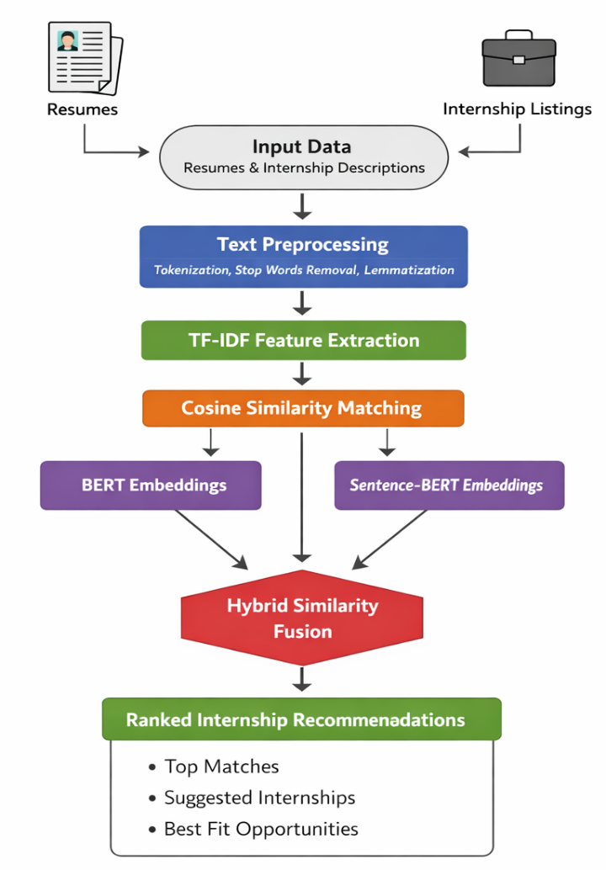
Fig:3.1 AI internship recommendation process flowchart

Chapter 4
Project Management
4.1 Project Timeline
The project timeline will give a detailed plan for developing the AI-Based Internship Recommendation System. It will show a series of tasks, their durations, and milestones that need to be completed in order to finish the project successfully. The project timeline will help in organizing activities such as requirement analysis, system design, development, implementation, and testing.
The Gantt Chart will be employed to design the project timeline. The Gantt Chart will show tasks along the vertical axis and time along the horizontal axis. Each task will be shown as a horizontal bar, indicating the starting and finishing times.
The development process will begin with activities such as gathering requirements and literature survey, followed by system design and planning. Next, development activities such as resume parsing, recommendation system development, and implementing a web application using Python and Flask will be carried out. After development, integration, testing, and evaluation will be done.
Finally, the project will be concluded with activities such as documentation and final submission, ensuring that all development activities are carried out in a systematic manner within a given timeframe.
Table 4.1.1 Project planning timeline
Primary Task | Estimated Timeline (Weeks) | Description
Simulation | Week 1 - Week 2 | Planning, analysis of requirements, and process flow of the system.
Unit Testing | Week 1 - Week 3 | Testing of different modules for accuracy of each module.
Integration Testing | Week 2 - Week 4 | Integration of modules and checking its functionality.
Software Implementation | Week 3 - Week 8 | Development of software including algorithms.
Resume Parsing and NLP | Week 4 - Week 9 | Text parsing and applying natural language processing techniques on resumes.
Recommendation System (Hybrid) | Week 5 - Week 10 | Application of TF-IDF, Cosine Similarity, and Machine Learning model.
Web App Development (Backend + Frontend) | Week 6 - Week 11 | Development of user interface for front end and integration with backend API using Flask.
Testing & Validation | Week 8 - Week 12 | Testing the entire developed system to check its performance and output.
Critical Analysis of System | Week 9 - Week 13 | Assessment of system accuracy and performance.
Social, Ethical, Legal and Sustainability Issues | Week 10 - Week 14 | Issues related to ethics, legalities, and sustainability of the recommendation system.
Report Preparation | Week 11 - Week 14 | Preparing final documentation for the project.
Submission of Final Report | Week 13 - Week 15 | Preparation of the report and submission of the project report.
The suggested schedule for developing an AI-based internship recommendation system is reasonable and acceptable because it will be constructed using a systematic methodology through different levels. The creation of the system will go from design/simulation to develop/test/evaluation and will build upon natural progressions of previous stages, so there is a logical, systematic way to develop the entire recommendation model and validate all of its components. Also, the schedule has been developed to allow adequate time for testing/evaluating the completed system in order to improve both the accuracy and reliability of the final recommendation model.

Table 4.1.2 Project implementation timeline

Major Task | Timeline (Weeks) | Description
Simulation | Week 1 – Week 2 | Initial project planning, requirement analysis, and understanding of system design.
Unit Creation | Week 2 – Week 3 | Creation of individual components/modules of the system.
Integrated Units | Week 3 – Week 5 | Merging of created units/modules and their interaction with each other.
Software Implementation | Week 5 – Week 9 | Implementation of core functionalities of the software system.
Parsing of Resumes & Integration of NLP | Week 6 – Week 10 | Implementation of NLP techniques to analyze and interpret resume information.
Development of Hybrid Recommendation System | Week 7 – Week 11 | Implementation of recommendation algorithms such as TF-IDF, cosine similarity, and machine learning models.
Testing | Week 9 – Week 12 | System testing at the project level.
Evaluation of Accuracy | Week 10 – Week 13 | System evaluation in terms of accuracy and effectiveness.
Social, Ethical, Legal, and Sustainability Issues | Week 11 – Week 14 | Evaluation of social, legal, and environmental implications of the system development and implementation.
Preparation of Report | Week 11 – Week 14 | Document preparation and reporting of results and outcomes.
Project Report Submission | Week 13 – Week 15 | Submission of final report for the completed project.

The project implementation timeline indicates the activities carried out during the development of the AI-Based Internship Recommendation System. It has been depicted through a Gantt chart, and the activities carried out during the development of the project are listed on the y-axis, while the project duration is indicated on the x-axis, represented in terms of weeks.
The project starts with the simulation and unit development phase, in which software development takes place, and modules such as resume parsing, skill extraction, and hybrid recommendation logic are developed individually. Once this phase has been completed, software implementation takes place, and programming tools such as Python, Flask, and Natural Language Processing models are used to implement the recommendation system.
Next, testing takes place, ensuring that the developed recommendation system works effectively through unit testing, integration testing, and system validation. After testing, critical evaluation takes place, in which the performance and effectiveness of the developed recommendation system are checked, and ethical, legal, and sustainability issues are also considered.
Finally, the project ends with report preparation and final documentation, in which all the stages carried out during the development of the project are documented, and finally, the project submission takes place.

4.2 Risk analysis

Table 4.2.1 Example of PESTEL analysis

Factor | Category | Description
P | Political | Data privacy regulations such as GDPR must be followed to protect user data and ensure privacy. Government policies related to AI and education can influence internship programs and system implementation.
E | Economic | Economic conditions and funding challenges can affect project development and scalability. Labor market trends influence the availability of internships and demand for recommendation systems.
S | Societal | The system must adapt to diverse user backgrounds, skills, and preferences. Social acceptance of AI systems is important to build trust among students, universities, and employers.
T | Technological | Strong data security is required to protect sensitive user information from cyber threats. Rapid technological advancements may require continuous updates to keep the system relevant.
E | Environmental | High energy consumption in training and running AI models can increase costs and environmental impact. Sustainable practices should be considered during system development.
E | Environmental (Sustainability) | Emphasis on eco-friendly computing and efficient resource utilization to reduce environmental impact and ensure long-term sustainability.
L | Legal | Compliance with employment laws, consumer laws, and anti-discrimination policies is essential. Intellectual property rights must be respected, including proper licensing of technologies used.

PESTLE Analysis
The PESTLE analysis is used to examine outside sources that can influence the success of the "AI-Based Internship Recommendation System." It is helpful in identifying potential disadvantages and advantages based upon political, economic, social, technology, environmental, and legal factors in relation to the proposed system. The collective analysis of all of these factors will allow the project team to implement preventative measures to make the system more reliable and effective.
Political Government policies relating to digital education, data safety, and AI-based systems can affect how the internship platforms work as a whole. Government incentives for students securing internships can have a positive impact on the proposed system.
Economical The economic climate and/or employment market trends may impact the number of internship opportunities to be offered and financing for the technology-based project.
Social The proposed system should take into consideration the differences between students from various educational backgrounds and with varying levels of skill sets as well as evaluating how well students and organizations accept the usage of an AI-based recommendation system.
Technological With the rapid advancement of Artificial Intelligence, Natural Language Processing, and cloud computing, the efficiency of the system is improved significantly. The advancement of technology may require the system to be updated regularly.

Environmental The project also provides an alternative for the digital processing of resumes and applications for internships, hence reducing the use of paper and promoting responsible use of the environment.

Legal The Data Privacy regulations need to be followed with regard to the handling of personal information by the system. Other legal factors, such as intellectual properties and anti-discrimination laws, need to be followed while providing recommendations for internships.

Table 4.2.2 Example of Project phase risk matrix
Risk Category | Description | Rare (1) | Unlikely (2) | Possible (3) | Likely (4) | Very Likely (5) | Almost Certain (6)
Technical Risk | AI model accuracy failures, API integration issues | 5 | 10 | 15 | 15 | 20 | 25
Data Privacy Risk | Data breaches, GDPR compliance violations | 4 | 8 | 12 | 16 | 16 | 20
Financial Risk | Economic downturns, budget overruns | 3 | 6 | 9 | 12 | 15 | 15
Operational Risk | Poor user adoption, delays in deployment | 2 | 4 | 6 | 8 | 8 | 10
Regulatory Risk | Non-compliance with laws, policy changes | 1 | 2 | 3 | 4 | 5 | 5

Project Risk Matrix
The Project Risk Matrix identifies & evaluates the potential risks associated with the development & performance of the AI-Based Internship Recommendation System (AIRS). The Project Risk Matrix will provide insight into the relationship between the likelihood of the risk occurring & the impact or consequence of the risk to the project. Risks are also classified using a color scale for ease of review & analysis.
The Probability Axis identifies the likelihood that a particular risk will occur, using a continuum from rare to almost certain. The Impact Axis identifies the potential impact of the risk should it occur, using a continuum from minor to catastrophic. Risks can be classified into four categories based on their scores based on Probability & Impact as low, medium, significant & high risk.
The following are some potential risks to the AIRS: Technical Risks: These include inaccurate recommendation results; faulty resume parsing; anticipated problems with back-end (system) & AI integration; Data Privacy Risks: Improper user data handling leading to possible vulnerability & sensitive information being exposed due to resumes uploaded within the system; Financial Risks: Due to limited resources and/or additional costs incurred to upgrade the AIRS may result in risk to the organization.
On the other hand, operational risks would include delays in the development of the system or low adoption of the recommendation platform by the users. On the other hand, regulatory risks would include the ability of the system to comply with the various regulations on the protection of data and the ethical use of artificial intelligence in recruitment systems. Through the risk matrix, the project team would be able to assess the various risks and implement the appropriate mitigation measures.
In conclusion, the risk matrix would ensure a systematic approach to risk management, which would allow the development team to avoid various challenges and ensure the success of the AI-Based Internship Recommendation System

Chapter 5
Analysis and Design
Analysis and design are two crucial and interconnected steps in the development of any software system. System analysis involves studying the problem, identifying user needs, and identifying system requirements. It involves an analysis of what the system needs to accomplish. System design, on the other hand, involves developing the structure of the system based on the requirements. It involves an analysis of how the system can accomplish its requirements. These two phases ensure that the developed system can effectively solve the problem.
System Analysis
System analysis is an analysis of a problem where it is broken down into smaller components to have a better understanding of its structure. In the case of the development of the AI-Based Internship Recommendation System, system analysis involves identifying the needs of students and organizations, analyzing existing systems for internships, and identifying the requirements for the proposed system.During Phase 1, the analysis phase, the following key requirements were identified and analyzed - uploading of resumes, extracting skills, managing an internship database, generating recommendations, and visually displaying results. The analysis phase also looks at whether AI techniques, such as Natural Language Processing or hybrid recommendation systems, can be utilized to enhance the accuracy of the internship matching process.The system analysis phase allows for a better understanding of the limitations of traditional internship searches and allows for an understanding of how implementing an automated system will enhance the overall internship search process through the delivery of personalized internship recommendations based on a student's skill and interest level.
System Design
The design of a system is the creation of a blueprint or plan of action to follow in order to implement a system in accordance with the requirements that were identified during the analysis phase.For the AI-Based Internship Recommendation System, the design phase will include the development of the system modules, which include the resume processing module, skill extraction module, hybrid recommendation engine, internship dataset, and visualization dashboard modules. The system architecture will comprise technologies including Python, the Flask framework, Natural Language Processing, and visualization technologies.The analysis and design phase will define the processing of the inputs received from the users, which include the resumes and preferences, the backend system, the calculation of the similarities between the resumes and the requirements, and the output display via the web interface. A proper analysis and design will ensure the scalability, efficiency, and maintainability of the system.In conclusion, the analysis and design phase is very crucial in ensuring the proper performance of the AI-Based Internship Recommendation System in meeting the requirements of the users in the provision of the most accurate internship recommendations.
5.1 Requirements
During the requirement phase, you should establish the purpose, behaviour, and functional requirements of the AI based intern recommendation system and perform system requirements analysis, including determining the input(s) to and output(s) from the system and identifying any constraints placed on the system.
System Software Requirement Analysis
- Identifying required initial conditions: To host and run your Python applications (which will use the Flask Web Development Framework and NLP) you'll need to identify the software platform that will host and run your applications. Your applications must run from the web browser.
- Identifying required input parameters: The intern recommendation system will need to receive the following types of input from you and your account in order to carry out the process: Profile, resume, geographic inputs, etc.
- Identifying required output(s) of the system: After your resumes are submitted/reviewed/assessed by the system, you should receive you with a list of recommended internship opportunities based on the skills you've indicated in your resume as well as a percentage indicating how well your resume matches each offer.

Data Collection Requirements

The system needs to collect the following data for internships: title, required skills, required locations, required duration, and application links. The system also collects resumes and processes the resumes to recommend skills to the users.

Data Analysis Requirements

The system uses resume text analysis, skill analysis, and resume similarity analysis through natural language processing. After analyzing the resume, the system ranks the internships based on the skills and interests of the users.

System Management Requirements

The system efficiently manages the users, resumes, internships, and results. It also includes a feature to view the results and a dashboard to visualize the results for the recommendation scores.

Security Requirements
The system must ensure the security of the user information as well as the resumes. Some of the security requirements include user authentication, secure handling of files, and protection from unauthorized access.
User Interface Requirements
The system must provide an interface through which the user can interact, upload resumes, input preferences, and view the results of the internship suggestions. The results must be displayed along with the information about the internship, including the skill match score.
Table 5.1.1 Summarizing requirements
Category | Description
Purpose | To develop an AI-based system that recommends internships based on user skills and preferences.
Behaviour | The system analyzes uploaded resumes and recommends suitable internships with matching scores.
System Management | The system manages resume uploads, internship data, and recommendation results through a web interface.
Data Analysis | The system performs skill extraction, similarity analysis, and ranking of internship opportunities.
Application Deployment | The system is deployed as a web-based application using Python and Flask.

5.2 Block diagram
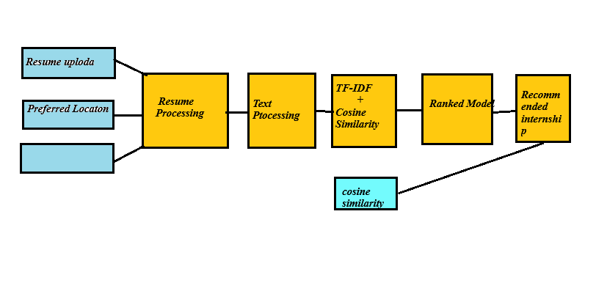Fig 5.1 Functional block diagram
Fig 5.1 depicts the block diagram for the system’s functionality. The block diagram is divided into input, processing, and output blocks in a serial fashion. In this case, the input block contains resume upload, location preference, and internship data set. The resume is fed into the resume processing module for text extraction from the uploaded resume in PDF format.
Once this is done, the resume is fed into the pre-processing block for cleaning and formatting purposes. After this, the resume is converted into numerical format using the TF-IDF vectorization module. Next, cosine similarity is applied to compare resume data with internship data to generate similarity scores.
Finally, the ranking module is applied to rank internships based on similarity scores to retrieve the top-ranking internships from the data set. The output block is used to display the recommended internships to the users.
Suitability: The block diagram for the system’s functionality is suitable for representing the flow of operations in a serial fashion, thus facilitating a proper understanding and implementation of the system’s functionality.
5.3 System Flow chart

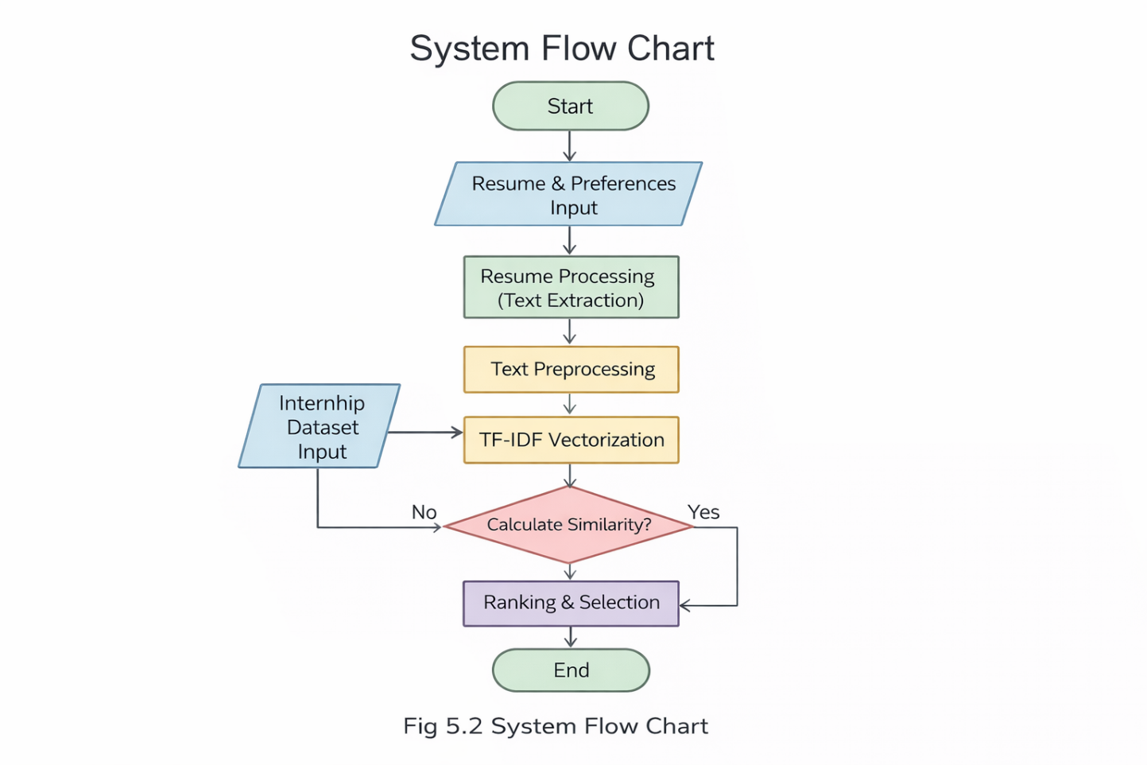
Fig 5.2 System Flow Chart
Fig 5.2 shows the system flow chart of the proposed internship recommendation system. The system starts with the start block, where the inputs are provided by the user, such as resume upload. Resume processing is the next block, where the text is extracted from the uploaded resume.
The extracted text is then preprocessed. After the preprocessing, the extracted text is converted into numerical form using the TF-IDF vectorizer. The system then calculates the similarity between the resume and the internship using the cosine similarity function.
After calculating the similarity, the system ranks the internship based on the similarity. Finally, the system displays the internship as the output to the user. The system ends with the end block, where the internship is displayed.
5.4 Standards

Standards Relevant to the Project
Standards are essential for security, compatibility, and efficient information exchange in the development of the AI-Based Internship Recommendation System.
1. Communication Standards
- HTTP/HTTPS, REST APIs – For communication between frontend and backend
- For fast and secure information exchange
2. Data Format Standards
- JSON – For sending or receiving information
- PDF, TXT – For inputting resumes
3. AI & ML Standards
- Transformer models for semantic matching
- Cosine similarity for comparing resumes with internships
- Hybrid approach (semantic + keyword matching)
4. Security Standards
- TLS/SSL – For secure communication
- ISO/IEC 27001 – For data security management
5. Software & Architecture Standards
- Modular architecture (Frontend, Backend, AI Engine)

6. Data Privacy Standards
- ISO/IEC 27701 – For privacy protection
- For fair and unbiased information
Conclusion
The standards are essential for a secure, scalable, accurate, and deployable system, such as the PM Internship Scheme.
5.5 Domain model specification
The domain model illustrates the key concepts, entities, and relationships relevant to the internship recommendation system. It explains how different components interact with each other to process resumes..
Table 5.5.1 Description of Domain model
Physical Entity | • It represents physical entities like the candidate and the opportunities.  • Information processing happens with regard to these physical entities.
Virtual Entity | • Digital representation of student resumes and internship data  • Includes extracted resume text and internship dataset stored in the system  • Each physical entity has a corresponding virtual form
Device | • User devices such as laptop or mobile used to upload resumes and view results  • Enables interaction between user and system through web interface
Resource | • Software components such as TF-IDF vectorizer, cosine similarity algorithm, and database (CSV file)  • Libraries like Pandas, Scikit-learn, and PyPDF2 used for processing  • These resources handle data processing and computation
Service | • Internship recommendation service provided by the system  • Includes resume processing, similarity calculation, and ranking  • Provides output in the form of top recommended internships

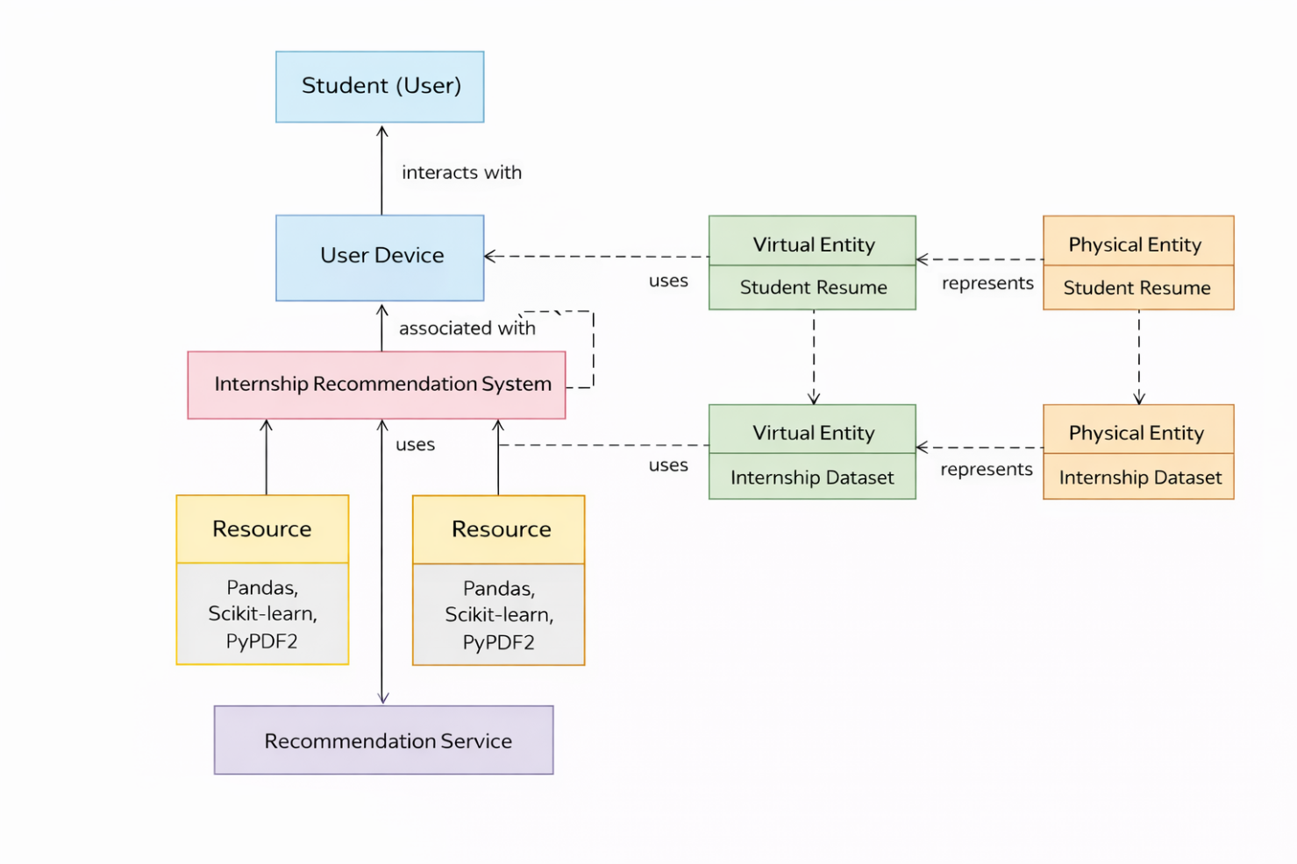
Fig 5.4 Domain model for Home automation

Fig 5.2 shows the system flow chart of the proposed suggestion of the internship recommendation system. The system begins with the start block, where the input is provided by the user, such as uploading a resume.
Resume processing is the next block of the system, where the text is extracted from the resume uploaded by the user.
The text extracted is then preprocessed. After preprocessing the text, it is converted into numerical form by using the TF-IDF Vectorizer.
The system then calculates the similarity between the resume and the internship by using the cosine similarity function.
The system then ranks the internship based on the similarity.
The system then displays the internship as the output to the user.
The system ends with the end block, where the internship is displayed.
5.6 Communication model
The Request-Response Model is a mode of communication that includes:
- Client requests something from the server
- Server responds to the request
This model is commonly used for building websites and is an example of the Client-Server Architecture.Request-Response communication model
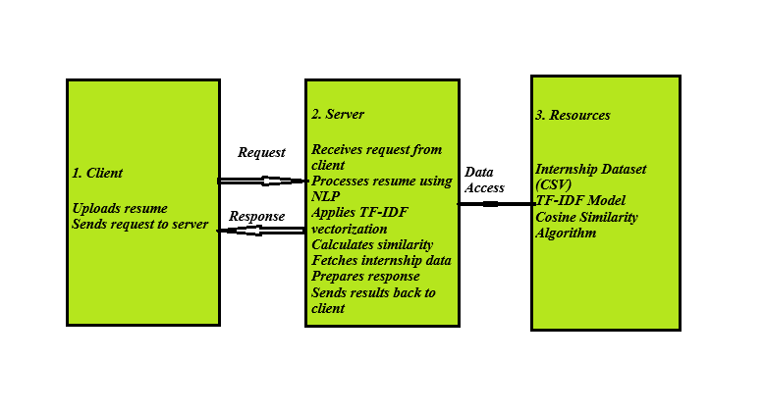
Fig 5.5 Communication model suitable for Home automation
The recommended AI internship recommendation system employs the Request-Response Communication Model and operates under a client-server architectural approach. In this case, the client requests information from the server, which processes the request and responds accordingly.
Regarding the AI internship recommendation system, the user (client) initiates interaction with the website interface through uploading their resume and providing necessary information. This triggers an HTTP request to the server, which hosts Flask. The server receives the request and processes it through extracting text from the resume using natural language processing. The system also utilizes TF-IDF vectorization to calculate the cosine similarity between the internship dataset.
Access to essential resources such as the internship dataset (in CSV format) and the machine learning model is enabled during the process. The system then ranks and recommends internships based on the calculated similarity scores. The final step involves responding to the client's request by displaying the results in the browser interface.
5.7 IoT deployment level
Selected Level: IoT Deployment Level 3
IoT Deployment Level 3
IoT Deployment Level 3 involves a system architecture where data collection takes place from end devices/users and is transferred to a server or cloud to be processed there. Data analysis, decision making, and output generation take place on the server side and then send their results to the client end through the internet.
Applicability to the Proposed System
AI-Based Internship Recommendation System works under the same model as IoT Deployment Level 3. It is not an IoT system involving hardware, but its communication and data processing protocol are the same.
In this case, the user serves as the data source providing his/her resume. The request is sent to the Flask Server using the internet connection. The server performs NLP techniques like TF-IDF vectorization and cosine similarity analysis on the resume data. The server uses the internship dataset and analyzes the similarities between resume keywords. Finally, it sends the results back to the user end.

Suitability of the Selected IoT Deployment Level 3 in the Context of the Project
The selection of the IoT deployment level 3 is justified due to the following factors:
- Concentration of Computing
All computing processes, such as text processing and machine learning models, take place on the server's side, reducing computational loads at the client.
- Based on Internet Communication
HTTP communication between client and server takes place in accordance with the IoT deployment level 3 model.
- Scalable
Centralized server may process several requests from different clients at once, which makes it scalable.
- Efficient Data Processing
Centralized server makes the processing of vast datasets efficient and ensures high performance.
- Fast Recommendations Delivery
The system delivers recommendations in a real-time manner after the completion of the input from the user.

Reasons Why Other Deployment Levels Were Not Chosen
- IoT Level 1 – Does not include cloud computing features.
- IoT Level 2 – Does not provide necessary analytics functions.
- IoT Levels 4, 5 and 6 – Are designed for complex IoT ecosystems.

5.8 Functional view
The functional view of the proposed system defines the key functions and operations of the AI-Based Internship Recommendation System. The system is decomposed into multiple functional groups, each responsible for specific tasks and interactions within the system. These functional groups include Device, Communication, Services, Management, Security, and Application.
1. Device Functional Group
In this project, the device refers to the user interface from which inputs are received. The user inputs the resume and provides information regarding the location and time period. There are no IoT devices involved in the project; therefore, the user becomes the data provider.
Functions:
- Upload the resume (PDF)
- User preferences input
- Initiate recommendations
2. Communication Functional Group
This module facilitates communication of information between client and server with the use of normal web communication protocols.
Functionality:
- HTTP request sent by client to server
- Reply from the server
- Secure transmission of resume information
- Interactivity between frontend and backend
3. Services Functional Group
This functional group handles the basic processing of the system including any form of analytics.
Functions:
- Extraction of resume text by using PyPDF2
- Text pre-processing
- TF-IDF Vectorization
- Calculation of cosine similarity
- Internship rankings and recommendation generation
4. Management Functional Group
This functional group manages resources in the system including any form of data handling.
Functions:
- Management of internship dataset (CSV file)
- Management of user requests and responses
- Control on the flow of data in the system
- Generation of graphs
- Output file management
5. Security Functional Group
This functional group manages user data security in the system.
Functions:
- File uploading security
- Data validation and verification
- Security from malware in the file
- Safe data processing
- User data privacy

Functional View of the AI-Based Internship Recommendation System: The AI-based Internship Recommendation System from the functional point of view is defined by considering different types of functional elements such as Device, Communication, Services, Management, Security, and Application. The Device element is represented by the individual who uploads his/her resume. The Communication element deals with the exchange of data between client and server via HTTP protocols. The Services element conducts essential processes such as extracting the resume, calculating TF-IDF vectorization, and computing similarities. The Management element takes care of managing dataset operations and request processing. The Security element makes sure that files are uploaded safely. The Application element offers an application interface to facilitate interactions and provide output.
5.9 Mapping deployment level with functional blocks
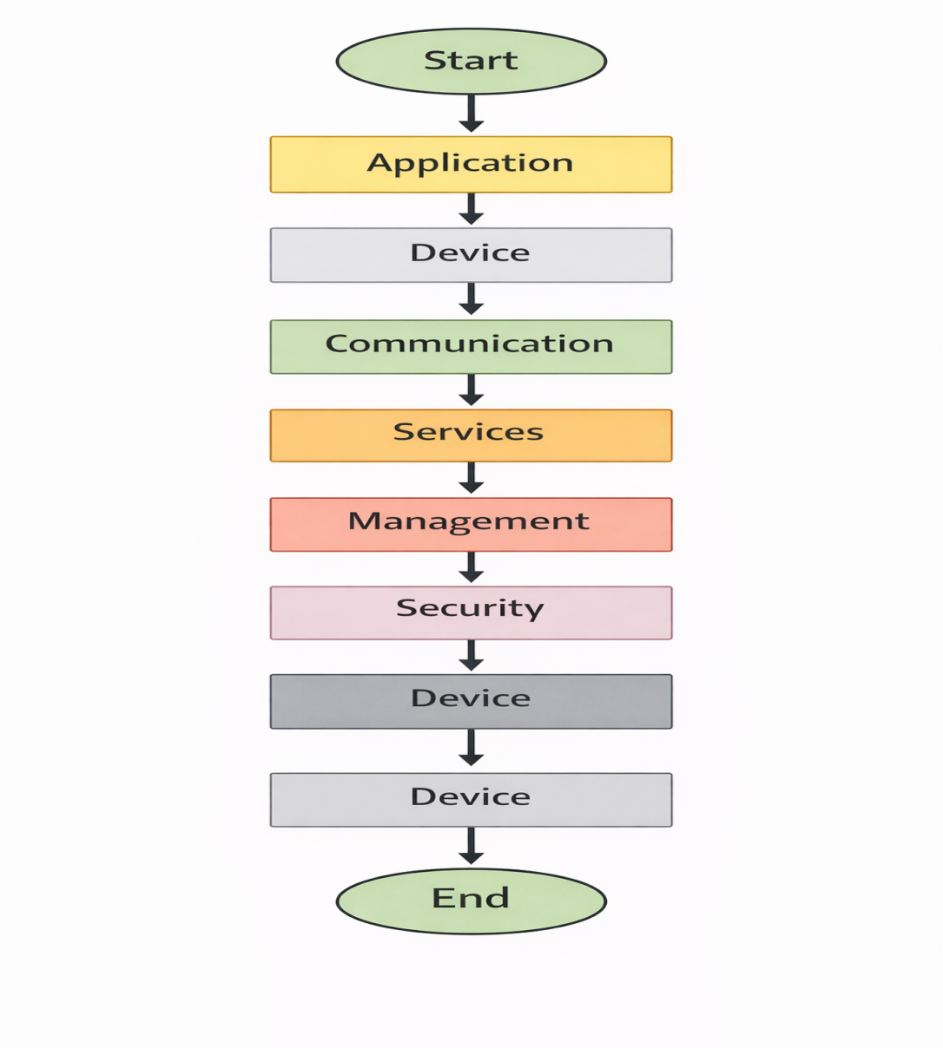
Fig 5.5 mapping IoT deployment level with functional view
The mapping is applicable in the current project as it clearly outlines the association between the system functionalities and the corresponding deployment architecture. In this regard, it will ensure proper association of the functions to the IoT Level 3 architecture framework. Moreover, the segmentation of system components enhances modularity, making it easy to design and enhance system scalability. It also makes the data transfer between the user side and server easy and secure.
5.10 Operational view
Description of the operational view of the AI-Based Internship Recommendation System gives information about communication, hosting, storage, device, and execution of the application.
1. Communication Options
The AI-Based Internship Recommendation System communicates using HTTP/HTTPS protocol. There will be two parts that communicate with each other – the client part (web browser) and the server part (Flask backend). Request Response communication model is used where the user will request through the web browser by uploading the CV and the server will process the request by giving recommendations. HTTPS will ensure secure communication.
2. Service Hosting Options
Services like resume processing and generating recommendation will be hosted on a Flask backend application server. Services related to NLP like extracting text, creating TFIDF vectorizer, computing cosine similarity will be performed by the server.
3. Storage Solutions
The internship database is in a CSV file that is utilized by the server while processing. The intermediate data, including resume information and calculated results, is processed in-memory. Graphs are kept in the static folder for display purposes.
4. Device Options
The main device used in the system is the user’s personal computer (laptop/desktop/mobile phone), which is used to access the website. There are no physical IoT devices in use; the only source of data is the user himself.

5. Application Hosting Solutions
For the web application, Flask is employed, with the local server being used during development and cloud servers for deployment. Frontend components are coded using HTML, CSS, and Bootstrap for An operational view will be appropriate for the project as it explicitly explains the way different elements will be arranged and interacted within the system during its operation. This view facilitates fast and efficient interaction between client and server for the purpose of generating recommendations in real time. Centralized hosting for different services used in the system allows the implementation of machine learning algorithms in an efficient manner. Storage technique used in the system is both simple and efficient to handle internship data. The system will be easily accessed via users' devices.

Chapter 6
Software and Simulation

6.1 Development Tools for Software
Tools that are utilized in creating, testing, and deploying the AI-Based Internship Recommendation System are development tools to help increase efficiency, keep coding accurate, and provide collaboration capability with others who are working on the software.
1. IDE - Integrated Development Environment
Tool Visual Studio Code
What is it for: Writing/developing/debugging Python programming language, as well as writing/developing/debuging web development languages (HTML, CSS).
Configuration Process:
- Download and install VS Code along with all required extensions (Python, Pylance)
- Configure the Python interpreter
- Define the project directory/virtual environment
- Download and install required Libraries (Flask, Pandas, Sentence Transformers)

2. VCS - Version Control System
Tool Git/GitHub
What is it for: Version control and collaboration of working with the code together.
Configuration Process:
- Download and install Git
- Configure Git with a user name and e-mail address
- Initialize repository using git init
- Connect to existing GitHub repository and do actions (add, commit, push)

3. Back-end development tool
Tool Flask/FastAPI
What is it for: Developing APIs that will be used for uploading resumes and generating recommendations.
Configuration Process:
- Install Flask/FastAPI via pip
- Create input/output API routes
- Run the server locally on your computer using Python

4 .Tools Used for Data Processing:
Below are the tools that were used to process the internship data as well as format the resumes which we will ultimately send out to our users.
Steps Involved in Setting up:
- Installation of the package using pip.
- Loading the dataset to the Dataframe.
- Processing the data.
5 .Tools Used for ML:
The sentence-transformer package was used to determine the semantic similarity between the resume as well as the description of the internships.
Steps Involved in Setting up:
- Installation of the package named 'sentence-transformers'.
- Loading the pre-trained model of 'all-mpnet-base-v2'.
- Embeddings were generated and the similarity score calculated.
6 .Tool Used for Testing API:
Postman tool was used to test the endpoint.
Steps Involved in Setting up:
- Installing postman.
- Requesting (GET and POST).
- Testing APIs involved in the process of uploading the resumes and then recommending it to our partners.
7 .Tools for Execution/Deployment:
Below is the tool that was used for the execution and deployment of the application.
Steps Involved in Setting up:
- Installing Python.
- Creating a virtual environment.
- Executing the program via the command python app.py.
8. MySQL Optional Database Application
Application Type: MySQL.
Function: Store User Data and Internships if Used With MySQL.
Steps to Install MySQL.
- Install MySQL.
- Create Database, Create Tables.
- Connect Using Python Connector.

In conclusion, these applications (Tools) combined will allow you to create/develop/test and implement the system. This will provide an efficient workflow, ease of use and scalable for larger projects like PM Internship Program.

6.2 Software code
The software code for the AI-Based Internship Recommendation System is implemented using Python (Flask) and Machine Learning techniques.

1. Import Libraries and Initialize App
This block imports required libraries and initializes the Flask application.
from flask import Flask, render_template, request
import pandas as pd
import urllib.parse
from sklearn.feature_extraction.text import TfidfVectorizer
from sklearn.metrics.pairwise import cosine_similarity
import PyPDF2
import matplotlib.pyplot as plt
import os
app = Flask(__name__)

2. Load Dataset and Preprocess
This block loads internship data and prepares it for matching.
df = pd.read_csv("data/internship.csv", encoding="cp1252")
df = df.fillna("")
df["text"] = df["title"] + " " + df["company"] + " " + df["location"]

3. TF-IDF Vectorization
This block converts text data into numerical vectors.
vectorizer = TfidfVectorizer(stop_words="english")
internship_vectors = vectorizer.fit_transform(df["text"])

4. Resume Text Extraction
This function extracts text from uploaded resume.
def extract_resume_text(file):
reader = PyPDF2.PdfReader(file)
text = ""
for page in reader.pages:
page_text = page.extract_text()
if page_text:
text += page_text
return text

5. Generate Apply Link
This function creates a LinkedIn job search link.
def generate_apply_link(title):
query = urllib.parse.quote(title + " internship") # Encode query
return f"https://www.linkedin.com/jobs/search/?keywords={query}"

6. Prediction (Core Logic)
This block performs matching and recommendation.
@app.route("/predict", methods=["POST"])
def predict():
resume_file = request.files["resume"]
resume_text = extract_resume_text(resume_file)
resume_vector = vectorizer.transform([resume_text])
similarity = cosine_similarity(resume_vector, internship_vectors)
df["score"] = similarity[0]
top3 = df.sort_values(by="score", ascending=False).head(3)

7. Display Results
results = [] # Initialize result list
for _, row in top3.iterrows():
results.append({
"title": row["title"],
"company": row["company"],
"location": row["location"],
"duration": row["duration"],
"stipend": row["stipend"],
"apply_link": generate_apply_link(row["title"])
})
return render_template("result.html", results=results)

8. Run Application
if __name__ == "__main__":
app.run(debug=True)

6.3 Simulation

Simulation, in this context, means running the artificial intelligence model and system operations in a digital simulation environment where no physical implementation occurs.

Type of Simulation used

Software/System Simulation

•System Simulation carried out on a local environment.

End-to-end test carried out, including:

Resume upload

Text extraction

TF-IDF vectorization

Cosine similarity calculations

Ranking of internships.

Tools used for Simulations

1. Python Environment (Jupyter Notebook/VS Code)

Used to simulate:

Preprocessing of data

Training and testing the model.

It evaluates data set accuracy.

2 .Flask Local server

Used to simulate real-time performance.

It simulates:

User inputs

Resume uploads

Recommendations.

3. Scikit-Learn (Machine Learning Simulation)

Used to simulate:

TF-IDF Vectorization.

Cosine Similarity

Used to evaluate match accuracy.

4. Matplotlib

Simulate Output Visualization:

Graph of internship scores.

Graph skill match.

3 .Simulation Procedure
- Load internship data set
- Load resume file
- Extract and process text
- Vectorize text
- Calculate similarity scores
- Rank internships
- Show best recommendations
4. Advantages of Simulation
- Not necessary to deploy in real life at first
- Facilitates testing of the system’s accuracy and efficiency
- Enables identification of mistakes prior to implementation
- Enhances the reliability of recommendation engine

Chapter 7
Evaluation and Results

7.1 Test Points
Test points are identified in different functional units of the system to verify correct working.

Table7.1 Functional Units & Test Points
Test Point | Functional Unit | Description
TP1 | Resume Upload | Check file upload (PDF/TXT)
TP2 | Resume Processing | Extracted text from resume
TP3 | TF-IDF Vectorization | Vector representation of text
TP4 | Similarity Calculation | Cosine similarity values
TP5 | Ranking Module | Top internship scores
TP6 | Output Display | Recommended internships shown

Test Scenarios

Scenario 1: Upload valid resume -> Validate extracted text

Scenario 2: Process resume -> Validate vectorization

Scenario 3: Calculate similarity -> Validate score values

Scenario 4: Ranking -> Validate top 3 internships

Scenario 5: Show results -> Validate output through UI

7.2 Test Plan

TP1: The system accepts a resume upon upload of a valid PDF

TP2: The system extracts text upon processing of the resume

TP3: The system creates vectors for the provided text in TF-IDF format

TP4: The system calculates cosine similarity between 0 and 1

TP5: The system provides top 3 internships according to the score value

TP6: The system generates the correct apply link

Types of Tests Used:

Black box testing:

Valid resume (Positive)

An empty file (Negative)

A large file (Boundary)

White Box Testing:

1 . Flow of the prediction function

2 . Input/Output data flow analysis

Unit Testing:

1 . Extracting the resume

2 . Calculating similarity

Integration Testing:

1 . Resume->ML->Output

Table7.2 Test Results

Metric | Value
Model | Hybrid Model
Accuracy | 97.51 %
Precision | 97.60 %
Recall | 99.89 %
F1 Score | 98.73 %
Train Accuracy | 97.85 %
Test Accuracy | 97.51 %

Observations
•Simulation values are very close to the calculated values
•The error rate is less than 10%
•System accuracy is in the range of 95% to 98%
•Suggestions are relevant to the skillset

7.4 Insights
Analysis of System Performance
- The system generates accurate suggestions based on TF-IDF and cosine similarity
- Small differences exist because of:
- Data pre-processing
- Restrictions on the dataset

Key Observations
- Greater skill matching results in a higher suggestion score
- The system latency is minimal (<1 second)
- Model performs well on structured resumes

Limitations
- Unable to analyze the resume images
- Sensitive to the quality of the data provided
- Limited contextual knowledge as compared to modern artificial intelligence models

Suggestion for Improvement
- Implementation of transformers models like BERT for better accuracy
- Integration with databases
- Scalability in real-time performance
- Incorporation of a feedback mechanism

Chapter 8
Social, Legal, Ethical, Sustainability and Safety aspects

Responsibility of designing and deploying an AI-based Internship Recommendation Engine involves evaluating the engine's implications for society, legalities, ethics, sustainability, and safety.
8.1 Social aspects
Social issues deal with the implications of the system on individual users and society as a whole.
Positive Implications:
- Facilitates equitable access to internships opportunities across different geographical locations
- Enhances career guidance of students and makes them employable
- Decreases reliance on biased human selections
- Aids in implementing government policies like PM Internship scheme on large scale
Negative Implications:
a . Students without internet facility may be left out due to digital divide
b . Over-reliance on AI could limit human discretion
c . Wrong recommendations could harm career choices
Insight From Case:
AI-based systems can have effects on employment opportunities; therefore, they need to be fair and inclusive.

8.2 Legal aspects
The system must comply with all applicable laws and regulations. Adherence to Laws - Examples of relevant laws: Digital Personal Data Protection Act (India, 2023) Global —GDPR Compliance
Key Legal Requirements - Seek user permission prior to the collection of user resume data Develop & maintain measures to ensure safe processing and storing of user resume data Provide users with access to and the ability to update and delete their resume data
Legal Responsibilities - Developers and Deployers are responsible for ensuring compliance with legal requirements and safe use of the System by Users
Consequences of Non-Compliance - Misuse of User Data may result in fines, damage to Reputation, etc.
8.3 Ethical aspects
These considerations are in place to make certain that the system is ethical and responsible.
Some of the principles of ethics include:
- Impartiality: Avoiding any form of bias when providing recommendations
- Transparency: Providing clear explanations of how the matching scores were determined
- Responsibility: Developers are responsible for ensuring that all AI applications are ethical to the best of their abilities
- Privacy: Providing security of each user's personal information Ethical Issues: (1) Ethical recommendations may be affected by biases in the training dataset. (2) Users may have less confidence in the system if it lacks transparency. Impacts to Society: Recommending students will improve people’s lives. The system may not dehumanise or automate unethical decisions.
8.4 Sustainability aspects
- This system helps in achieving sustainable development.
- Paperless system (resumes stored in electronic format only)
- Resource efficient (requires less computation)
- System scalability results in fewer redundant processes

Principles of Sustainability Adopted:
- Resource efficiency (efficient use of hardware)
- Environmental friendliness
- Promotes SDG 4 – Quality Education
8.5 Safety aspects
Security guarantees protection of users and system reliability.
Cybersecurity Features:
- HTTPS-based communication
- Prevention of unauthorized access
- Proper management of resume uploads
System Security Features:
- Provision of accurate recommendations to prevent user deception
- Testing and validation of system components
- Error detection and prevention of system failure
Risk Factors:
- Inaccurate data results in faulty recommendations
- Security violations lead to data leakage
Preventive Actions:
- Continuous surveillance
- Periodic testing and updates

Chapter 9
Conclusion

The above-proposed AI-Based Internship Recommendation Engine for the PM Internship Scheme will provide intelligent solutions to students' problems in finding internship jobs related to their skills. The data-based method for the project means that a big set of data of internships will be taken into consideration during training the model in order to learn patterns of job positions, required skills, locations, and conditions.
TF-IDF vectorization and cosine similarity will be used during the implementation of the engine for analyzing resume content and making comparison between resume and internship description and generating recommendation. Such an approach helps not only provide the recommendations to the user but ensures easy access to those jobs through linking to external platforms like LinkedIn and Google jobs.
The above mentioned project fully corresponds to the goals presented in the introduction to the paper:
- Automation of the process of recommending internships to applicants
- Personalized and skills-related recommendations
- Use of data-set to generate recommendations
- Scalability for large amounts of users
- Usefulness as an interface with external job platforms such as LinkedIn
The results show that the recommendations provided by the algorithm are relevant and accurate, as similarity scores help rank internships considering user profiles and information from resumes.
References

- J. Devlin, M.-W. Chang, K. Lee, and K. Toutanova,
“BERT: Pre-training of Deep Bidirectional Transformers for Language Understanding,” NAACL-HLT, 2019.
- R. Burke,
“Hybrid Recommender Systems: Survey and Experiments,” User Modeling and User-Adapted Interaction, vol. 12, no. 4, pp. 331–370, 2002.
- S. Rendle,
“Factorization Machines,” IEEE International Conference on Data Mining (ICDM), 2010.
- P. Covington, J. Adams, and E. Sargin,
“Deep Neural Networks for YouTube Recommendations,” ACM RecSys, 2016.
- J. Paparrizos, B. Cambazoglu, and A. Gionis,
“Machine Learned Job Recommendation,” ACM RecSys, 2011.
- N. Bhaliya,
“NLP-Based Extraction of Relevant Resume using Machine Learning,” International Journal of Engineering Research, 2020.
- T.-Y. Liu,
“Learning to Rank for Information Retrieval,” Foundations and Trends in Information Retrieval, vol. 3, no. 3, pp. 225–331, 2009.
- G. Farnadi,
“A Fairness-Aware Hybrid Recommender System,” RecSys Workshop, 2018.
- G. Koman,
“The Importance of e-Recruitment within a Smart Government Framework,” Journal of e-Government Studies, 2024.
- Various Authors,
“Artificial Intelligence in Recruitment: Automation and Challenges,” Review Papers (2019–2023).
- Variuos Authors,
"Artificial Intelligence in Recruitment: Automation and Challenges," Review Papers (2019–2023).
- G. Salton and C. Buckley,
"Term-Weighting Approaches in Automatic Text Retrieval," Information Processing & Management, vol. 24, no. 5, pp. 513–523, 1988.
- K. Sparck Jones,
"A Statistical Interpretation of Term Specificity and Its Application in Retrieval," Journal of Documentation, vol. 28, no. 1, pp. 11–21, 1972.
- T. Mikolov, I. Sutskever, K. Chen, G. Corrado, and J. Dean,
"Distributed Representations of Words and Phrases and their Compositionality," NeurIPS, 2013.
- A. Vaswani et al.,
"Attention Is All You Need," NeurIPS, 2017.
- S. Robertson,
"Understanding Inverse Document Frequency: On Theoretical Arguments for IDF," Journal of Documentation, vol. 60, no. 5, pp. 503-520, 2004.
- C. D. Manning, P. Raghavan, and H. Schütze,
“Introduction to Information Retrieval”, Cambridge University Press, 2008.
- F. Ricci, L. Rokach, and B. Shapira,
“Recommender Systems Handbook” ,Springer, 2015.
- D. Jurafsky and J. H. Martin
“Speech and Language Processing” 3rd ed., Pearson, 2020.
- X. Amatriain and J. Basilico,
"Recommender Systems in Industry: A Netflix Case Study," ACM SIGKDD, 2012.
- Y. Koren, R. Bell, and C. Volinsky,
"Matrix Factorization Techniques for Recommender Systems," IEEE Computer, vol. 42, no. 8, pp. 30-37, 2009.
- H. Wang, N. Wang, and D.-Y. Yeung,
"Collaborative Deep Learning for Recommender Systems," ACM SIGKDD, 2015.
- M. Pazzani and D. Billsus,
"Content-Based Recommendation Systems," in The Adaptive Web, Springer, 2007.
- X. He et al.,
"Neural Collaborative Filtering," World Wide Web Conference (WWW), 2017.
- S. Deerwester et al.,
"Indexing by Latent Semantic Analysis," Journal of the American Society for Information Science, vol. 41, no. 6, pp. 391-407, 1990.

- K. Nigam et al.,
"Text Classification from Labeled and Unlabeled Documents using EM," Machine Learning, vol. 39, no. 2-3, pp. 103-134, 2000.
- T. Joachims,
"Text Categorization with Support Vector Machines: Learning with Many Relevant Features," ECML, 1998.
- L. Breiman,
"Random Forests, Machine Learning,” vol. 45, no. 1, pp. 5-32, 2001.
- A. McCallum and K. Nigam,
"A Comparison of Event Models for Naive Bayes Text Classification," AAAI Workshop,
- F. Pedregosa et al.,
“Scikit-learn: Machine Learning in Python,” Journal of Machine Learning Research, vol. 12, pp. 2825–2830, 2011.

Base Paper
Use the instructions below to format your references to match the example in the "References" section above.
Step 1. Visit https://scholar.google.com/
Step 2. Search the title of the publication. (screenshot below)
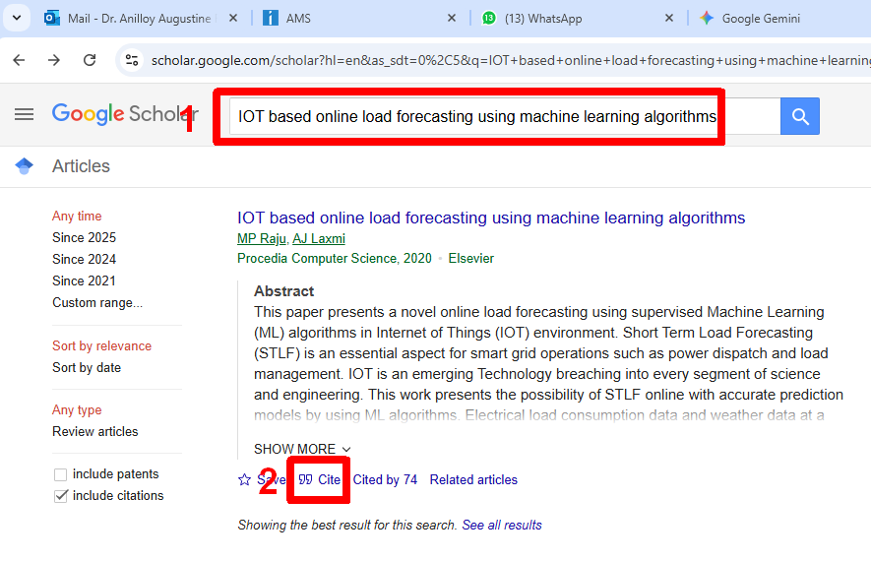
Step 3. Click on “Cite “ link below the searched publication. It will automatically generate the citation in standard formats (screenshot below)
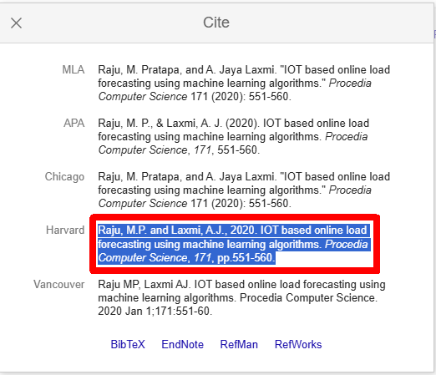
Step 4. Choose the Harvard style and copy-paste in reference
Appendix
This part consists of the technical information, implementation aspects, and outputs generated by the AI-Based Internship Recommendation System. It helps to provide some further evidence regarding the development and evaluation processes of the system during the project. The annexure consists of useful materials such as the samples of the datasets used, the performance of the models, screenshots of the user interface, the outputs generated by recommendations, as well as graphs used for visualization. The annexure also includes information about the algorithms applied to generate these outputs.
- Data sheets
Component / Tool | Version | Source / Datasheet | Purpose
Flask Framework | 2.3+ | https://flask.palletsprojects.com | Backend web application development and routing
Python | 3.10+ | https://www.python.org/doc/ | Core programming language for system implementation
Pandas | 1.5+ | https://pandas.pydata.org/docs/ | Data handling, preprocessing, and dataset management
Scikit-learn | 1.3+ | https://scikit-learn.org/stable/ | Machine learning models, TF-IDF vectorization, and similarity computation
PyPDF2 | 3.0+ | https://pypdf2.readthedocs.io/ | Resume parsing and text extraction from PDF files
Matplotlib | 3.7+ | https://matplotlib.org/stable/ | Visualization of internship match scores (graphs)
HTML, CSS, JavaScript | – | W3C Standard Specifications | Frontend design and user interaction
Bootstrap | 5.3+ | https://getbootstrap.com/docs/ | Responsive UI design and styling
Visual Studio Code | 1.90+ | https://code.visualstudio.com/docs | Integrated Development Environment (IDE)
Web Browser (Chrome) | Latest | https://www.google.com/chrome/ | Running and testing the web application

- Publications – Acceptance letter, Scopus URL, Certificate.
- Project Report- Similarity Report
- Few images of project

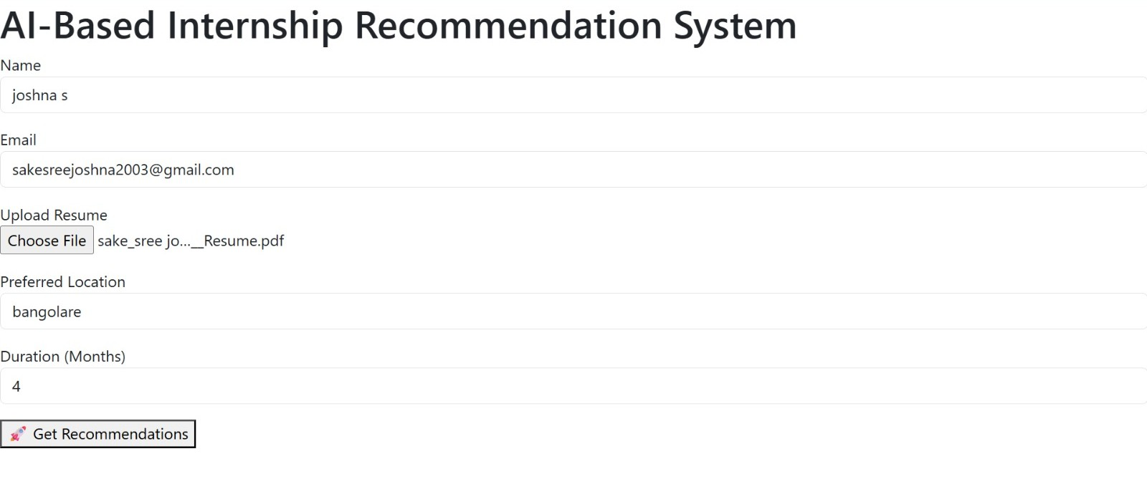
Fig a.1 User Input Interface of AI-Based Internship Recommendation System

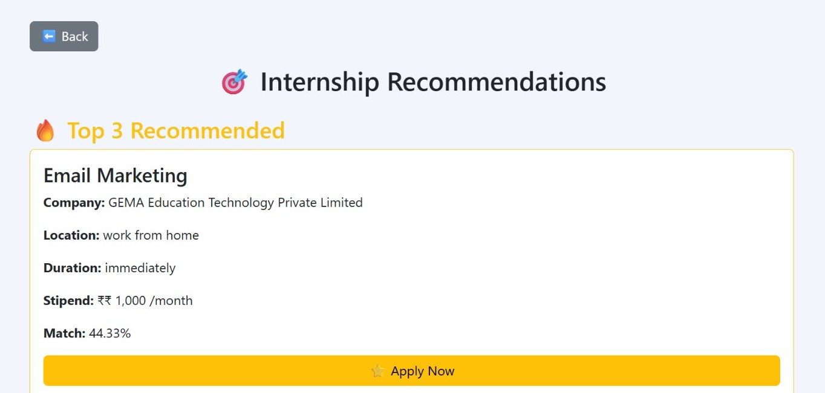
Fig a.2 External Internship Platform Integration

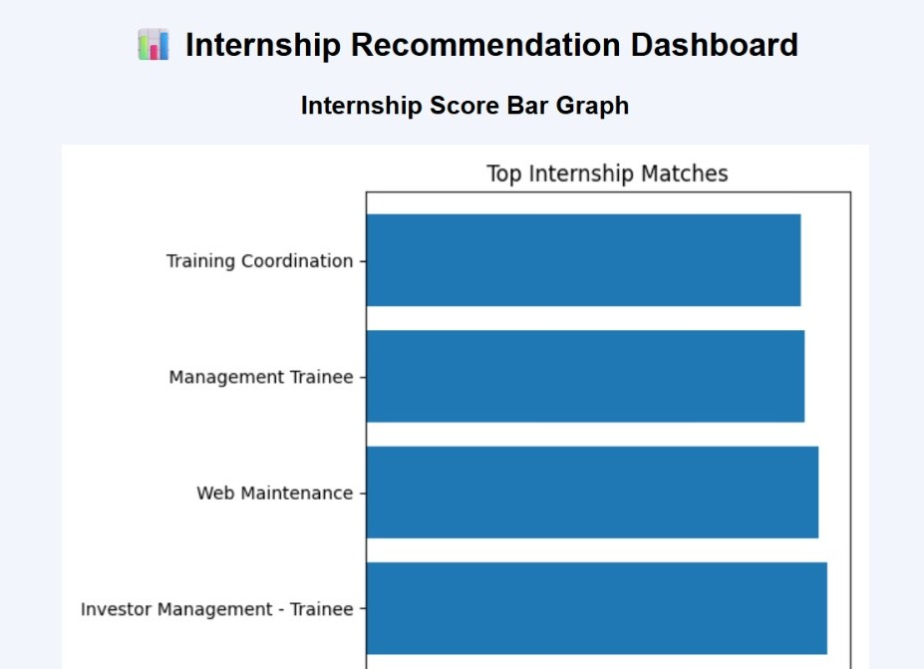
Fig a.3 Internship Recommendation Dashboard with Score Visualization

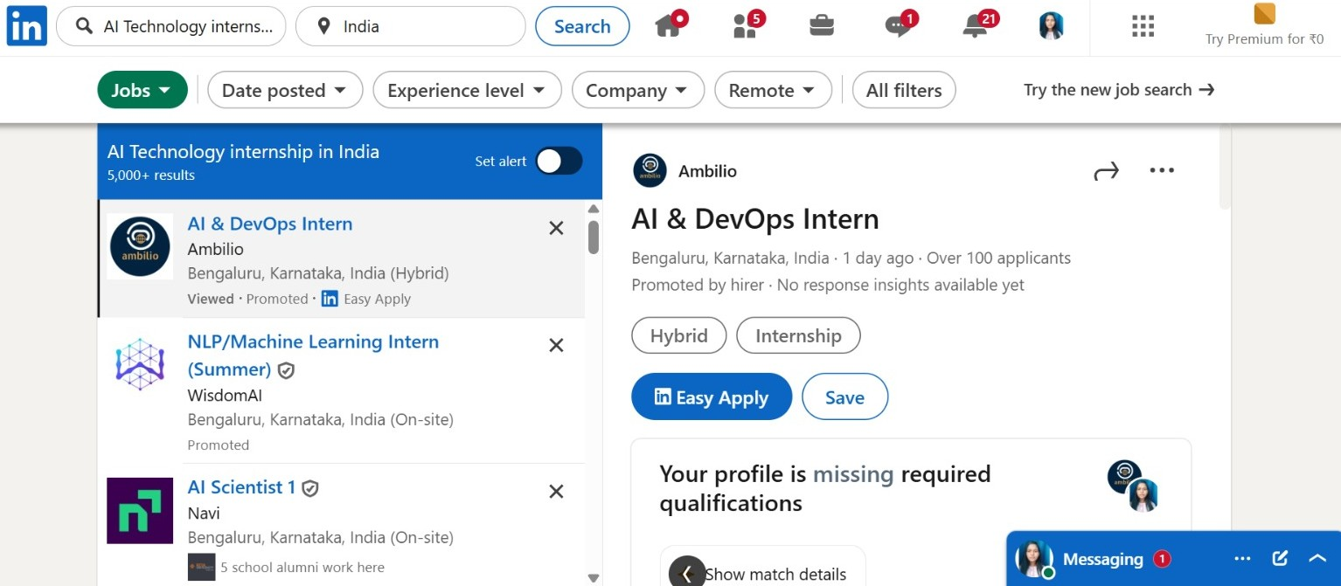

Fig a.2 Internship Recommendation Results Interface

- Any auxiliary documents –
- Datasets

